Cetacean Strandings Paper Outline

*Introduction*

* Strandings as an indicator of ocean and cetacean health
* Updated information is important for population monitoring, keeping tabs on trends and changes, and examining emerging conditions or diseases, particularly in light of oceanographic changes
* Range of species that strand in the PNW
* Overall goal: Update Norman et al. and learn something new by extending the timeline and highlighting a few case studies (e.g., increase humpbacks and harbor porpoises, while decrease in Dall’s)
* Summarize expectations/anticipated results
* Recap importance of work

*Methods*

* Summarize level A stranding data

*Results*

* Balaenopterids
* Odontocetes
  + Delphinids
  + Phocoenids
  + Ziphiids

Temporal trends

* Average annual strandings
* Which species strand the most?
  + See excel table with numbers and proportions for each species (secies.csv)
* Most common “causes” or findings (illness, injury, disease, HI) this might be good to put into table form too.
  + We don’t have a stranding cause right now, just HI = Y/N/CBD. We could make a table with the proportions of certain HI case types, but that’ll take me half a day to put together (losing the HI type was an error on my part when creating the clean dataset - I have to go back to the original to retrieve that info, which is on my list)
* Is there an increasing, stable, or decreasing trend for any of the species?

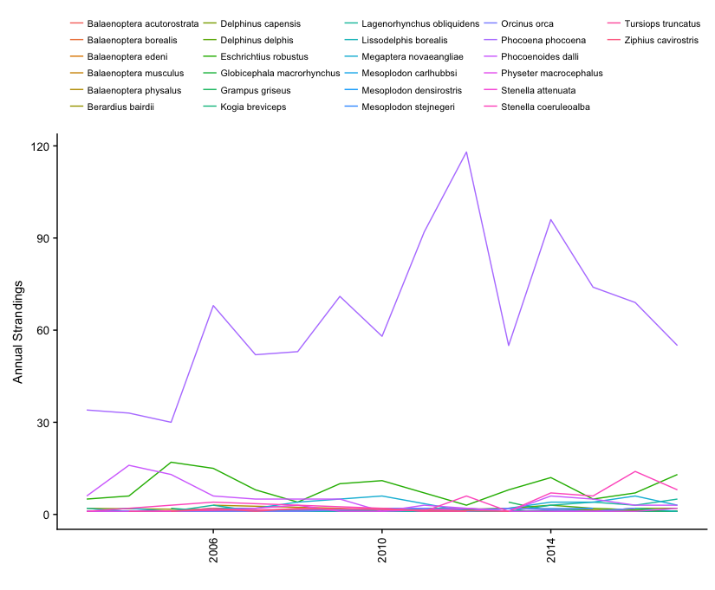

* Is there an increasing trend in the number of HI cases?

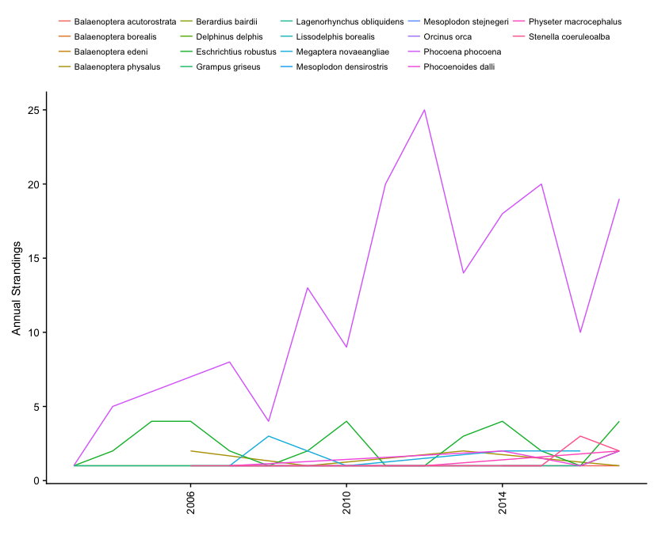

* 🡪 highlight a case study of two species
* Compare to trends in Norman et al., if/where relevant, though save the bulk of that for the discussion

Spatial trends

* + Where do most of the toothed and baleen strandings occur – is it the same, different from each other? Great question – had not thought of looking at it specifically in terms of these two Orders.

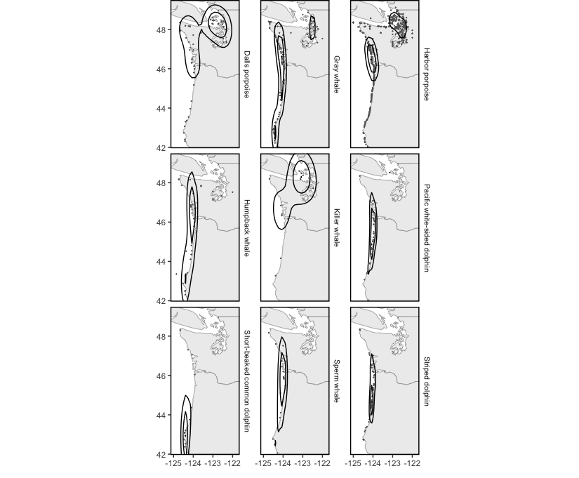

* Are certain regions experiencing any kind of increasing or decreasing trend? Don’t know if this is the right place to put this, but could we do something like a principal component analysis to determine if there is a relationship between oceanographic features (e.g., presence of an El Nino during years of stranding, average sea surface temp the year of stranding) and presence of extralimital strandings or changes in species stranding numbers (e.g., fewer Dall’s, but more harbor porpoise). I don’t really know how to run a PCA of if this analysis would be the right one for assessing any oceanographic relationship and strandings. Throwing some thoughts out.
* 🡪 highlight a case study of one species with interesting changes in spatial distribution of strandings
* 🡪 and/or find a case study species that ties all kinds of changes together, such as one that exhibits an increasing trend in a certain area for a certain age/sex class

Seasonal trends

* Average monthly strandings – this would be good graphically. I ran a very simple Bayesian analysis in a harbor porpoise calving seasonality paper that recently came out in which posterior probabilities were calculated for proportions of calves stranded by season and by month. I’m not super versed in Bayesian techniques, but I could probably run something very simple.
* See seasonal excel table mimicking Norman et al (seasonal_sp.csv)

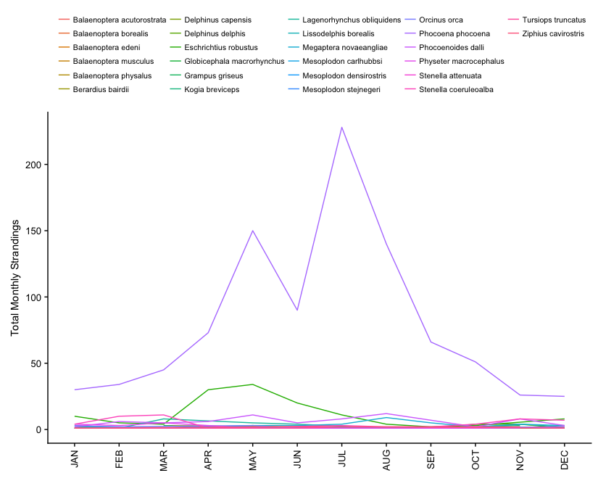

* Do strandings for the two categories (baleen, toothed, etc) exhibit a seasonal pattern? Or maybe this question might be better answered with a PCA? The dependent variable could be baleen or toothed species (0,1) and then look at relationship to seasons, months, 5-year intervals, etc. Again, thinking out loud. Please feel free to suggest other methods you may have more experience with.
* 🡪 interesting case study of highly seasonal trend?
  + Either hp or grays
* 🡪 interesting types of HI cases that exhibit a seasonal trend? John and Jessie would be good to ask about this too.

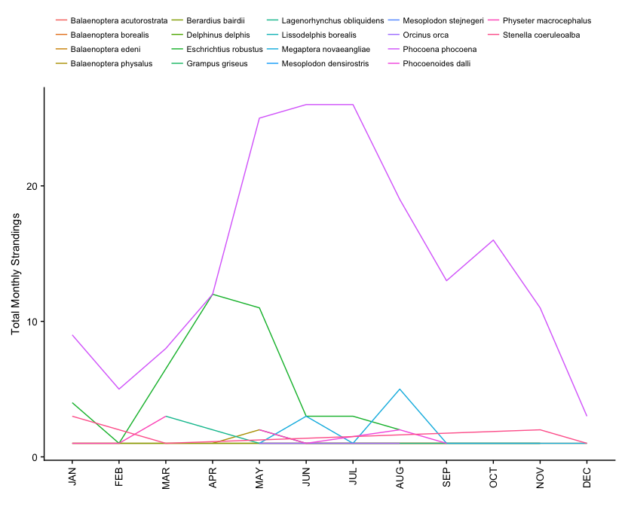

gray whale seasonal map

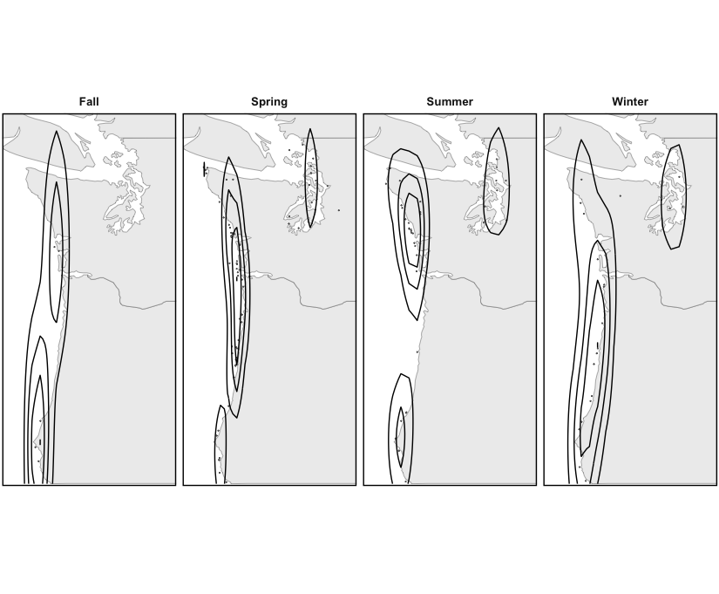

Harbor porpoise seasonal map

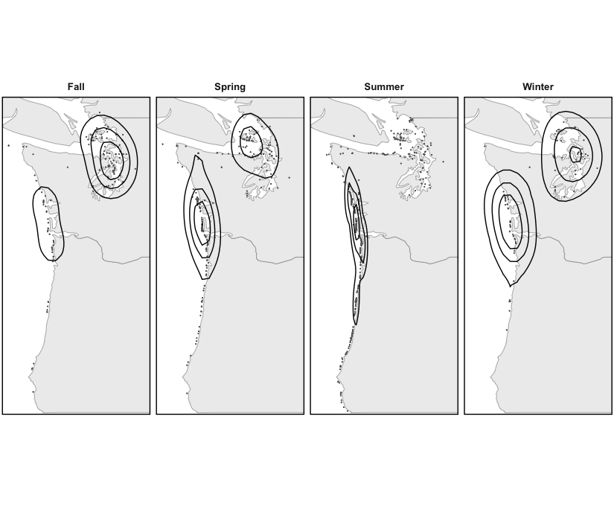

*Discussion*

* Recap most interesting summary of findings
* Discuss comparison with Norman et al. and what this longer time period can tell us about changes in reporting, strandings, and/or the environment

Once we get some of the tables, graphs, charts, and analyses done, we can begin to put the actual paper together.